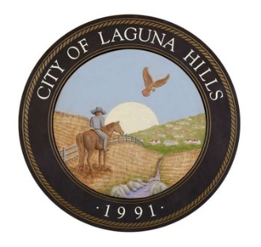**City of Laguna Hills**

**Building/Safety Division**

**MULTI-UNIT DWELLING SUBMITTAL CHECKLIST**

**ELECTRIC VEHICLE CHARGING STATION (EVCS)**

**Submittal Documents Required\***

Plans may be submitted in-person during counter hours or online at <http://lagunahillsca.gov/eplancheck>. For more information on electronic plan check submittals please see our Plan Check Submittal Instructions handout that can be found at <http://lagunahillsca.gov/planchecksubmittalinstructions>.

* **Plan Sets (3 sets, 11” X 17” or larger)**
  1. **Site/Plot Plan**
     1. Show full property extent (property lines, parking areas, structures, etc.).
     2. List relevant property information, such as existing parking counts and ratios.
     3. Provide a detailed site plan showing where the charging unit is located within the parking garage or lot, and any necessary accessibility improvements
     4. As required by type of EVCS, installation mounting method, and local jurisdiction requirements provide necessary structural details.
  2. **Electrical Plan**
     1. Provide a complete electrical single line drawing signed by an Electrical Engineer or a C10 Contractor showing the main service, sub panels, and proposed EVCS.
     2. Include size of overcurrent protection devices (in amperes) for main service, sub panels, disconnects and EVCS circuit supply.
     3. Show conduit sizes and types, and conductor sizes and types.
     4. Provide a trenching detail and call out trench work in the scope of work on the plan if trenching is required. Trenching may result in a structural plan review if conduit trenches undermine foundations.
     5. Note electrical feeder requirements when trenching structure to structure (CEC 225). The feeder from structure to structure should be noted in the scope of work. Verify that trenching is in compliance of minimum cover requirements for wiring methods or circuits (18” for direct burial per CEC 300).
     6. Provide EVCS manufacturer's specification sheets showing Nationally Recognized Testing Laboratory (NRTL) approved listing mark for indoor or outdoor (UL 2202/UL 2200).
* **Electrical Load Calculation Worksheet**
  1. Include existing and proposed load to estimate if existing electrical service will handle the new load from EVCS and wiring methods. Note: Unless electrical service equipment is 100% rated, the calculated load demand on the main service shall not exceed 80% of the nameplate rating of the main service over-current protection device (OCPD). (CEC 625.40) Provide a panel schedule for existing panels.

**\*All plans and documents listed above must be provided for non-residential EVCS at time of permit submittal for plan check prior to issuance. Plans will be subject to an hourly plan check charge in addition to the permit fees.**

**Inspections Required**

**Final Inspection** is required when system is complete and operative

**Permit Fees**

**EV Charging Outlet** $17.46 per outlet

**Permit Issuance** $82.16

**Record Retention** $2.05/page 11”x17” or smaller ($3.08/page larger than 11”x17”)

**State Title 24 fee** $1.00 per $25,000 of project valuation

**State CASp fee** $4.00

Installations must be completed by a licensed electrical contractor (C-10). (Local Regulations, California Electrical Code CEC Article 625) Plans must show conformance with the California Electrical Code Title 24, Part 3, the California Building Code (Volume 1 and 2), Title 24, Part 2, and other applicable local municipal codes.